Olympics Medal Data Analysis using SQL and Power BI

EXECUTIVE SUMMARY: This project focuses on the analysis of historical Olympic medal data with the objective of extracting meaningful insights related to country performance, athlete achievements, gender participation, and sport-wise dominance across different Olympic years. The purpose of the project was to transform raw sports data into structured, insightful information that can support data-driven understanding and decision-making.
The project began with data preprocessing, where the raw dataset was cleaned using Microsoft Excel. This included removing unnecessary columns, handling missing values, standardizing data formats, and ensuring data consistency. After cleaning, the dataset was converted into CSV format to make it suitable for database ingestion.
The cleaned data was then stored in an Oracle SQL database, where a structured table was designed to hold Olympic medal records. SQL queries were written and executed to perform various analyses such as identifying top medal-winning countries, analysing medal trends over the years, evaluating athlete performance, understanding gender-wise participation, and determining sports with the highest medal counts.
To enhance interpretability and presentation, Power BI was used to create interactive dashboards and visualizations. These dashboards presented insights through bar charts, line graphs, and pie charts, allowing clear visualization of trends and patterns in Olympic performance data.
As a result of this project, key insights were successfully derived, including identification of dominant countries and athletes, trends in medal distribution over time, gender participation patterns, and sport-wise medal contributions. The project demonstrates practical application of data cleaning, SQL-based analysis, and business intelligence visualization, providing a strong foundation in real-world data analytics practices.

Business / Problem Statement
Large volumes of sports data are generated during international events like the Olympic Games, but raw data alone does not provide meaningful insights without proper processing and analysis. The main challenge addressed in this project is the lack of clear, consolidated insights from raw Olympic medal data, making it difficult to identify performance trends, medal dominance, and participation patterns across countries, sports, and genders.
This project bridges that gap by transforming raw Olympic medal data into structured, analysable information using data cleaning, SQL-based analysis, and interactive visualizations. The resulting insights help stakeholders understand historical performance trends and support data-driven reporting and decision-making in sports analytics.

Objectives of the Project
The key objectives of this project are as follows:
- To clean and preprocess raw Olympic medal data to ensure accuracy, consistency, and reliability
- To store the cleaned dataset in a structured relational database using Oracle SQL
- To perform analytical queries using SQL in order to extract meaningful insights from historical data
- To analyse medal distribution based on countries, athletes, years, sports, and gender
- To visualize analytical results using interactive Power BI dashboards for better interpretation
- To derive actionable insights that highlight trends, patterns, and dominance in Olympic performance

TOOLS & TECHNOLOGIES

Tool |  | Purpose
Excel |  | Data cleaning & preprocessing
Oracle SQL |  | Data storage & querying
SQL Developer |  | Query execution
Power BI |  | Data visualization

DATA CLEANING & PREPROCESSING
Microsoft Excel was used for data preprocessing. Unnecessary columns were removed, missing values were handled, and data formats were standardized. The cleaned dataset was exported in CSV format for database ingestion.

ANALYTICAL APPROACH
The analytical approach of this project focuses on transforming raw Olympic medal data into meaningful insights through structured preprocessing, analysis, and visualization. The process began with data cleaning in Microsoft Excel, where inconsistencies, missing values, and unnecessary columns were removed, and data types were standardized to ensure accuracy and reliability.
The cleaned dataset was then imported into an Oracle SQL database, where a relational table was created for efficient data storage and retrieval. SQL queries using aggregation, filtering, grouping, and ranking techniques were applied to analyze medal distributions across countries, years, athletes, sports, and genders.
Finally, the analyzed data was visualized using Power BI through interactive dashboards and charts, enabling easy interpretation of trends and comparisons. This structured approach ensured a smooth transition from raw data to actionable insights, providing a clear analysis of Olympic performance trends.

KEY ANALYSES & INSIGHTS
Analysis 1: Country-wise Medal Distribution
Objective:
To identify the country with the highest number of medals won in Olympic history.
SQL Query Used:
SELECT country, COUNT(*) AS total_medals
FROM olympics
GROUP BY country
ORDER BY total_medals DESC;
Query Explanation:
This query calculates the total number of medals won by each country by counting all medal records and grouping the data country-wise. The results are sorted in descending order of total medals, ensuring that the country with the highest medal count appears at the top.
Result:
The analysis shows that the Soviet Union has won the highest number of medals, followed by the United States and East Germany, indicating their historical dominance in the Olympic Games.
Visualization:
A horizontal bar chart in Power BI representing total medals won by each country.
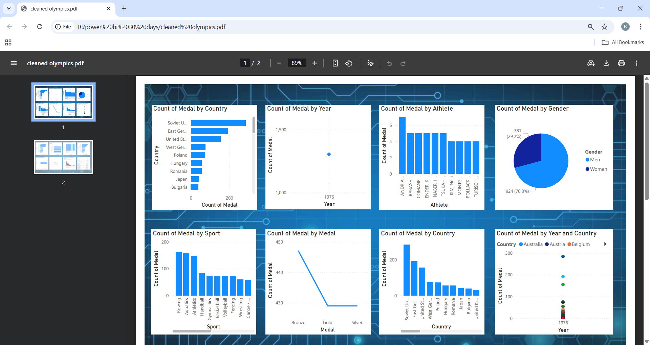
Analysis 2: Year-wise Medal Distribution
Objective:
To analyze the distribution of medals across different Olympic years and observe historical trends over time.
SQL Query Used:
SELECT year, COUNT(*) AS total_medals
FROM olympics
GROUP BY year
ORDER BY year;
Query Explanation:
This query calculates the total number of medals awarded in each Olympic year by counting all medal records and grouping the data year-wise. The results are ordered chronologically to clearly display trends in medal distribution over time.
Result:
The analysis highlights variations in the total number of medals awarded across different Olympic years, reflecting changes in the number of participating events and athletes over time.
Visualization:
A line chart in Power BI illustrating total medals awarded per Olympic year.
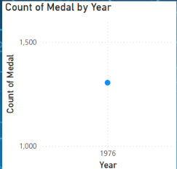

Analysis 3: Top 10 Medal-Winning Athletes
Objective:
To identify the top 10 athletes with the highest number of medals won in Olympic history.
SQL Query Used:
SELECT *
FROM (
SELECT athlete, COUNT(*) AS medal_count
FROM olympics
GROUP BY athlete
ORDER BY medal_count DESC
)
WHERE ROWNUM <= 10;
Query Explanation:
This query calculates the total number of medals won by each athlete by grouping the data athlete-wise. The results are sorted in descending order of medal count, and only the top 10 athletes are selected using ROWNUM.
Result:
The analysis highlights the most successful Olympic athletes based on medal count, showcasing consistent high performance at the international level.
Visualization:
A bar chart in Power BI displaying the top 10 medal-winning athletes.
Analysis 4: Gender-wise Medal Distribution
Objective:
To analyze medal distribution across genders and understand participation trends in the Olympic Games.
SQL Query Used:
SELECT gender, COUNT(*) AS total_medals
FROM olympics
GROUP BY gender;
Query Explanation:
This query counts the total number of medals won by each gender by grouping the data gender-wise, enabling comparison of medal distribution between male and female athletes.
Result:
The analysis provides insights into gender-based participation and performance, highlighting differences in medal contributions across genders.
Visualization:
A pie chart in Power BI representing gender-wise medal distribution.
Analysis 5: Sports with the Highest Medal Count
Objective:
To identify the sports that have contributed the highest number of medals in Olympic history.
SQL Query Used:
SELECT sport, COUNT(*) AS total_medals
FROM olympics
GROUP BY sport
ORDER BY total_medals DESC;
Query Explanation:
This query calculates the total number of medals won in each sport by grouping the data sport-wise and sorting the results in descending order to identify the most medal-rich sports.
Result:
The analysis reveals the sports that have historically dominated the Olympics in terms of medal distribution.
Visualization:
A bar chart in Power BI showing total medals by sport.
Analysis 6: Medal Type Distribution
Objective:
To analyze the overall distribution of Gold, Silver, and Bronze medals in Olympic history.
SQL Query Used:
SELECT medal, COUNT(*) AS count
FROM olympics
GROUP BY medal;
Query Explanation:
This query calculates the total number of medals for each medal type by grouping the data medal-wise, providing an overview of the distribution of Gold, Silver, and Bronze medals.
Result:
The analysis shows a balanced distribution of medal types, reflecting the standard Olympic awarding structure.
Visualization:
A pie chart in Power BI representing the distribution of Gold, Silver, and Bronze medals.
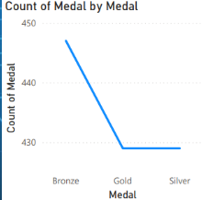
Analysis 7: Countries with the Most Gold Medals
Objective:
To identify countries that have won the highest number of Gold medals in Olympic history.
SQL Query Used:
SELECT country, COUNT(*) AS gold_medals
FROM olympics
WHERE medal = 'Gold'
GROUP BY country
ORDER BY gold_medals DESC;
Query Explanation:
This query filters the dataset to include only Gold medals, then counts and groups them country-wise. The results are sorted in descending order to highlight the top Gold medal-winning countries.
Result:
The analysis reveals countries that have consistently performed at the highest level by securing the most Gold medals.
Visualization:
A bar chart in Power BI displaying Gold medals won by each country.

Analysis 8: Year-wise and Country-wise Medal Performance
Objective:
To examine medal performance trends of different countries across Olympic years.
SQL Query Used:
SELECT year, country, COUNT(*) AS total_medals
FROM olympics
GROUP BY year, country
ORDER BY year, total_medals DESC;
Query Explanation:
This query calculates medal counts for each country in every Olympic year by grouping the data year-wise and country-wise. The results are ordered to allow comparison of country performance over time.
Result:
The analysis highlights how different countries’ performances have evolved across Olympic editions, identifying periods of dominance and consistency.
Visualization:
A stacked bar chart or table visualization in Power BI showing country-wise medals across years.
Analysis 9: Top 5 Sports by Gold Medals
Objective:
To identify the top five sports that have produced the highest number of Gold medals in Olympic history.
SQL Query Used:
SELECT *
FROM (
SELECT sport, COUNT(*) AS gold_medals
FROM olympics
WHERE medal = 'Gold'
GROUP BY sport
ORDER BY gold_medals DESC
)
WHERE ROWNUM <= 5;
Query Explanation:
This query filters the data to include only Gold medals, groups the results sport-wise, and orders them in descending order of Gold medal count. The top five sports are selected using ROWNUM.
Result:
The analysis highlights the sports that have historically dominated the Olympics in terms of Gold medal achievements.
Visualization:
A bar chart in Power BI showing the top five sports by Gold medals.
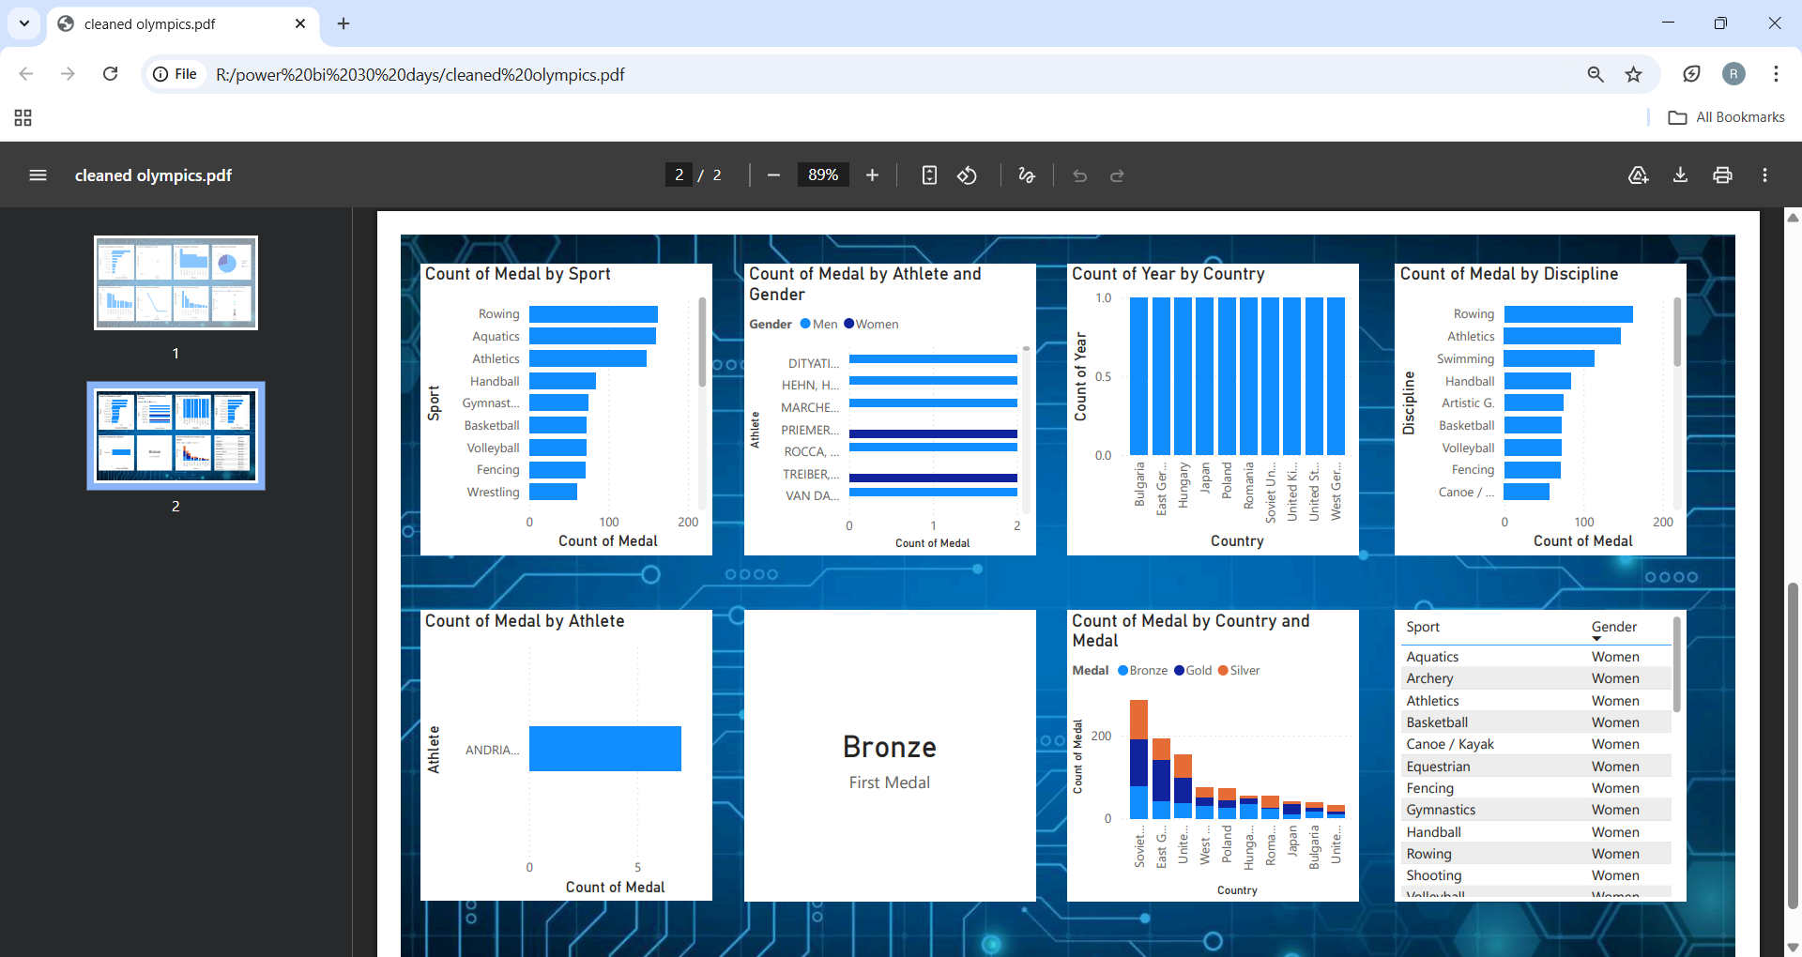

Analysis 10: Medal Count by Athlete and Gender
Objective:
To compare medal counts of athletes based on gender and analyze gender-based performance trends.
SQL Query Used:
SELECT athlete, gender, COUNT(*) AS total_medals
FROM olympics
GROUP BY athlete, gender;
Query Explanation:
This query calculates medal counts by grouping the data based on athlete and gender, enabling a comparison of medal achievements between male and female athletes.
Result:
The analysis provides insights into individual athlete performance while highlighting gender-wise contributions in Olympic medal achievements.
Visualization:
A table or clustered bar chart in Power BI displaying medal counts by athlete and gender.

Analysis 11: Countries with the Highest Olympic Participation
Objective:
To identify countries with the highest number of Olympic participations over the years.
SQL Query Used:
SELECT country, COUNT(DISTINCT year) AS participation_years
FROM olympics
GROUP BY country
ORDER BY participation_years DESC;
Query Explanation:
This query counts the number of distinct Olympic years in which each country participated, allowing identification of countries with long-term and consistent Olympic involvement.
Result:
The analysis reveals countries with sustained participation in the Olympic Games, reflecting strong sports infrastructure and commitment.
Visualization:
A bar chart in Power BI displaying countries by number of participation years.

Analysis 12: Medal Distribution by Discipline
Objective:
To analyze medal distribution across different Olympic disciplines.
SQL Query Used:
SELECT discipline, COUNT(*) AS total_medals
FROM olympics
GROUP BY discipline
ORDER BY total_medals DESC;
Query Explanation:
This query calculates the total number of medals awarded in each discipline by grouping the data discipline-wise and ordering the results by medal count.
Result:
The analysis identifies disciplines that have contributed the most medals in Olympic history.
Visualization:
A bar chart in Power BI showing total medals by discipline.
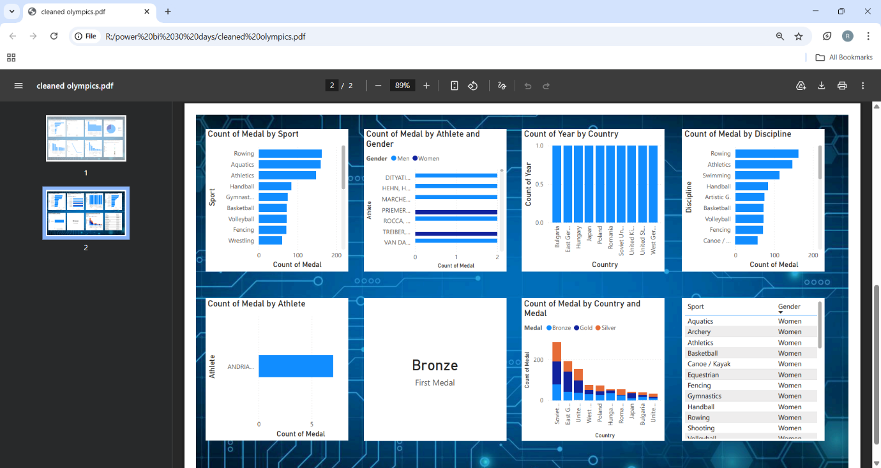

Analysis 13: Medal Distribution by Country and Medal Type
Objective:
To analyze how Gold, Silver, and Bronze medals are distributed across different countries.
SQL Query Used:
SELECT country, medal, COUNT(*) AS medal_count
FROM olympics
GROUP BY country, medal
ORDER BY country;
Query Explanation:
This query groups the data by country and medal type to calculate how many medals of each category were won by every country.
Result:
The analysis provides a detailed breakdown of medal composition for each country, offering deeper insight into performance quality.
Visualization:
A stacked bar chart or matrix table in Power BI showing medal types by country.

Conclusion
This project successfully transformed raw Olympic medal data into meaningful insights using data cleaning, SQL-based analysis, and interactive visualizations. By analyzing medal distribution across countries, years, athletes, sports, genders, and medal types, the study revealed key performance trends and patterns in Olympic history. The use of Oracle SQL enabled efficient data querying, while Power BI dashboards improved data interpretation and storytelling. Overall, the project demonstrates the importance of data analytics in sports performance evaluation and decision-making.
References
- Olympic Medal Dataset (publicly available data source)
- Oracle SQL Documentation
- Microsoft Power BI Documentation
- Microsoft Excel Documentation

